**Object Oriented Programming Lab**

**Fall’20**

**Department of Computer Science**

|  |  |
| --- | --- |
| **STUDENT NAME** | Abdullah Muhammad Ibrahim |
| **STUDENT ID** | SP20-BSCS-0027 |
| **SECTION** | AM |
| **ASSIGNMENT NO.** | 07 |
| **DUE DATE** | Due Dec 17, 11:59 PM |
| **SUBMITTED ON** | 2020 Dec 15 |

***Mohammad Ali Jinnah University***

**Object Oriented Programming Lab**

**Fall’20**

**Question 1/Task 1:**

Create a class with a method that prints &quot;This is parent class&quot; and its subclass with

another method that prints &quot;This is child class&quot;. Now, create an object for each of the

class and call

1 - method of parent class by object of parent class

2 - method of child class by object of child class

3 - method of parent class by object of child class

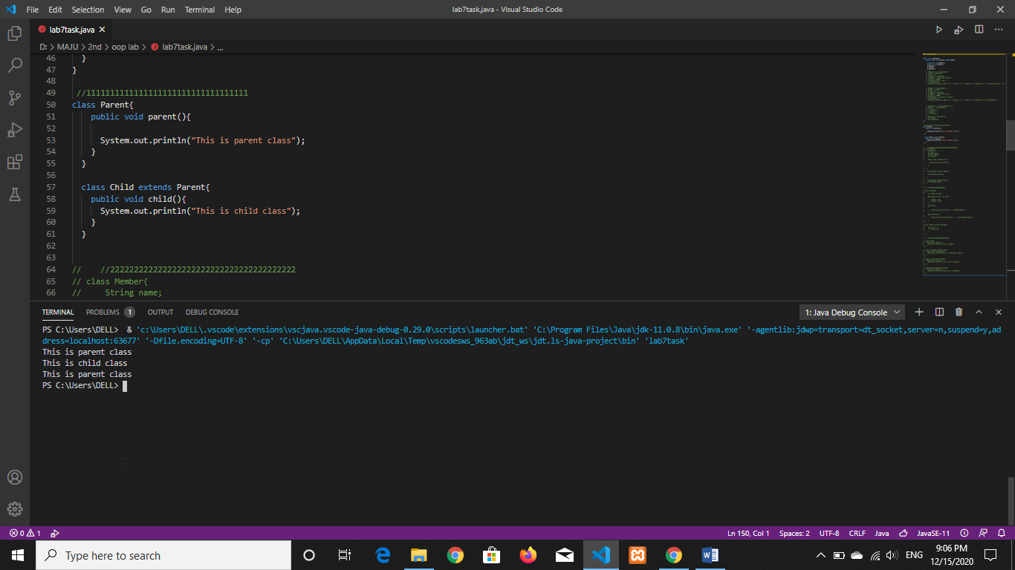

**Question 2/Task 2:**

Create a class named &#39;Member&#39; having the following attributes/data members:

1 - Name

2 - Age

3 - Address

4 - Salary

It also has a method named &#39;printSalary&#39; which prints the salary of the members.

Two classes &#39;Employee&#39; and &#39;Manager&#39; inherits the &#39;Member&#39; class. The

&#39;Employee&#39; and &#39;Manager&#39; classes have data members &#39;specialization&#39; and

&#39;department&#39; respectively. Now, assign name, age, address and salary to an

employee and a manager by making an object of both of these classes and print the

same.

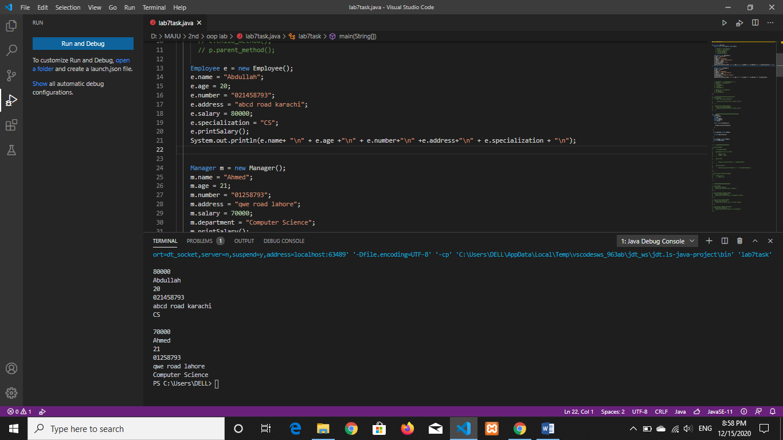

**Question 3/Task 3:**

Create a class named &#39;Rectangle&#39; with two data members &#39;length&#39; and &#39;breadth&#39; and

two methods to print the area and perimeter of the rectangle respectively. Its

constructor having parameters for length and breadth is used to initialize length and

breadth of the rectangle.

Let class &#39;Square&#39; inherit the &#39;Rectangle&#39; class with its constructor having a

parameter for its side (suppose s) calling the constructor of its parent class as

&#39;super(s,s)&#39;. Print the area and perimeter of a rectangle and a square.

Area = length * breadth

Perimeter = 2 * (length + breadth)

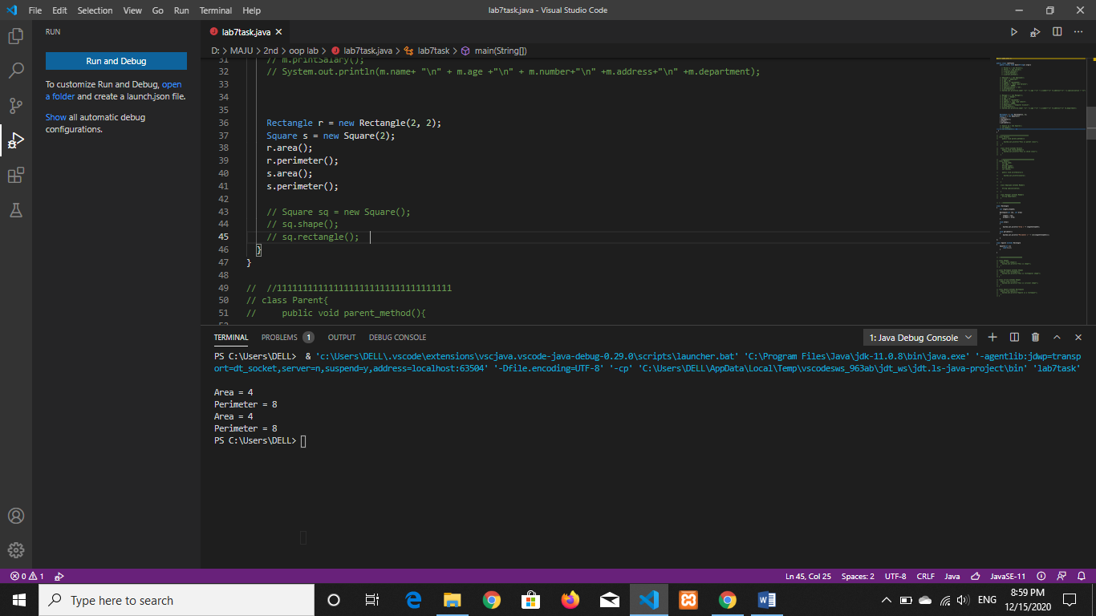

**Question 4/Task 4:**

Create a class named &#39;Shape&#39; with a method to print &quot;This is shape&quot;. Then create

two other classes named &#39;Rectangle&#39;, &#39;Circle&#39; inheriting the Shape class, both having

a method to print &quot;This is rectangular shape&quot; and &quot;This is circular shape&quot;

respectively. Create a subclass &#39;Square&#39; of &#39;Rectangle&#39; having a method to print

&quot;Square is a rectangle&quot;. Now call the method of &#39;Shape&#39; and &#39;Rectangle&#39; class by

the object of &#39;Square&#39; class.

